SHEET -13 – PACKAGE MANAGEMENT – YUM & DNF

1. yum install firefox

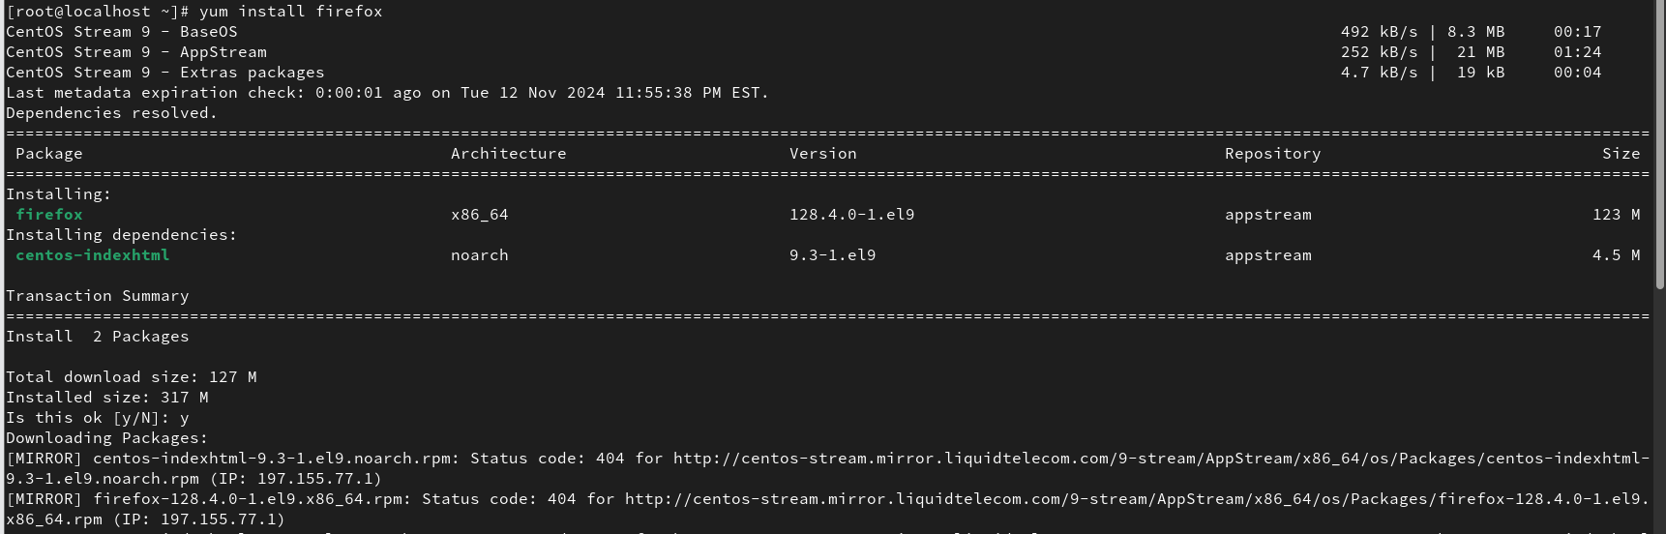

1. dnf install mysql

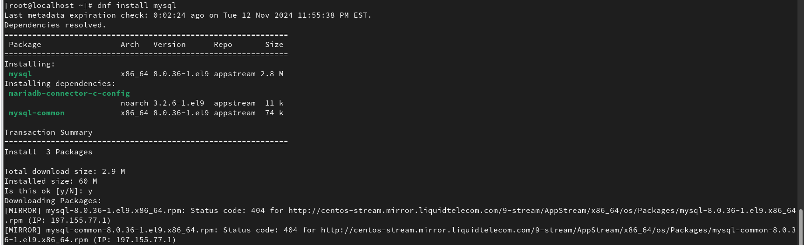

1. yum remove firefox

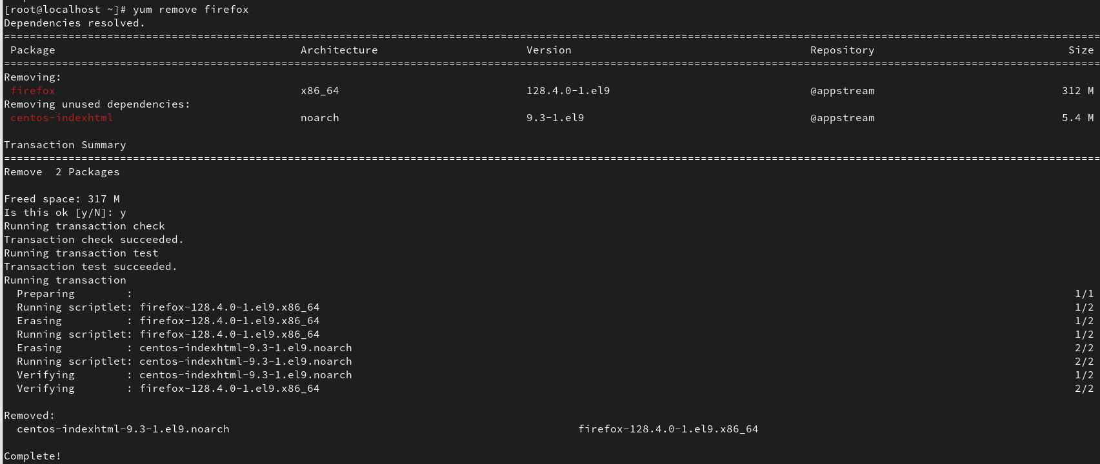

1. dnf remove mysql

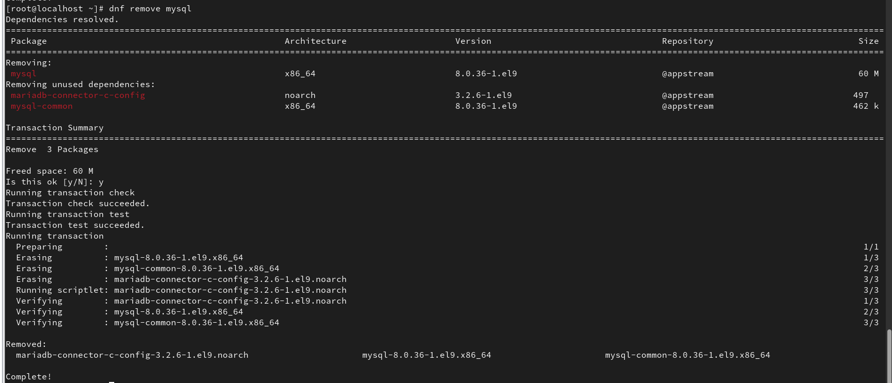

1. dnf install mysql nginx

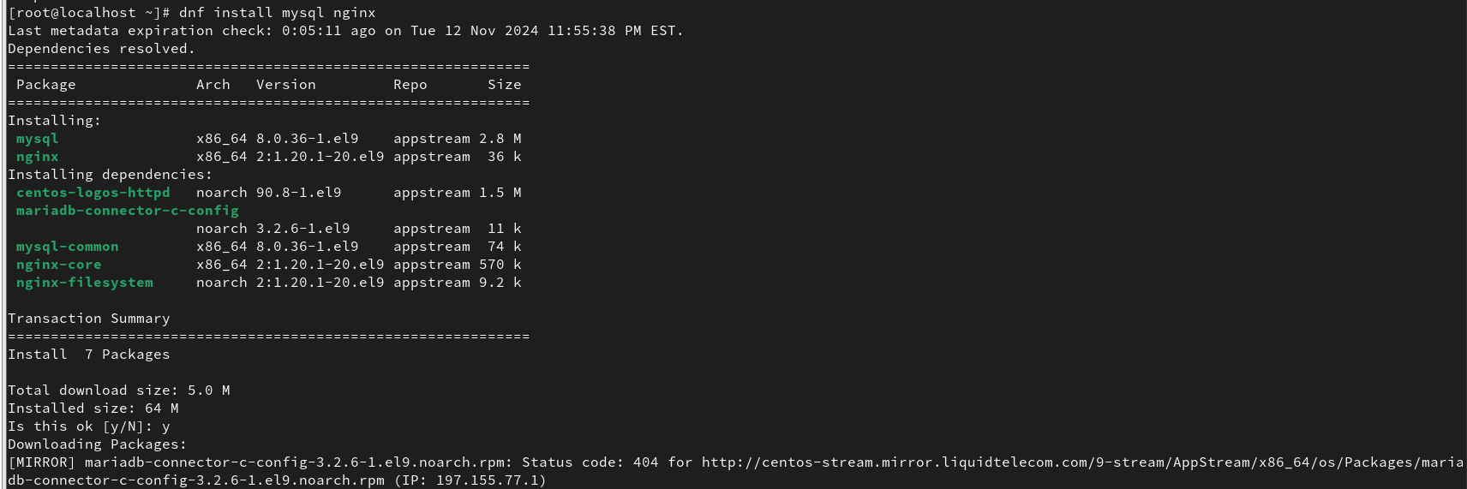

1. yum install openssh

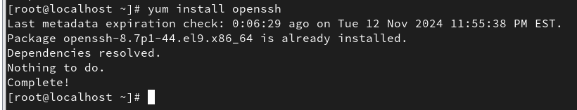

1. yum /dnf update openssh

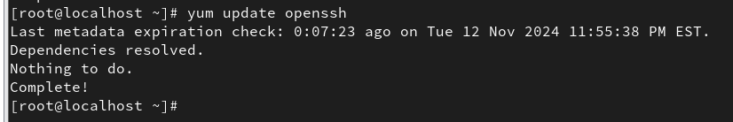

1. yum list openssh – list the package (check with rpm -qa openssh)

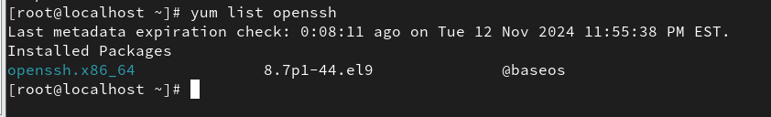

1. dnf list openssh

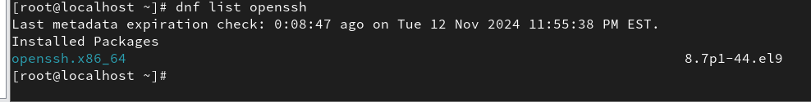

1. yum search ftp – search for a package

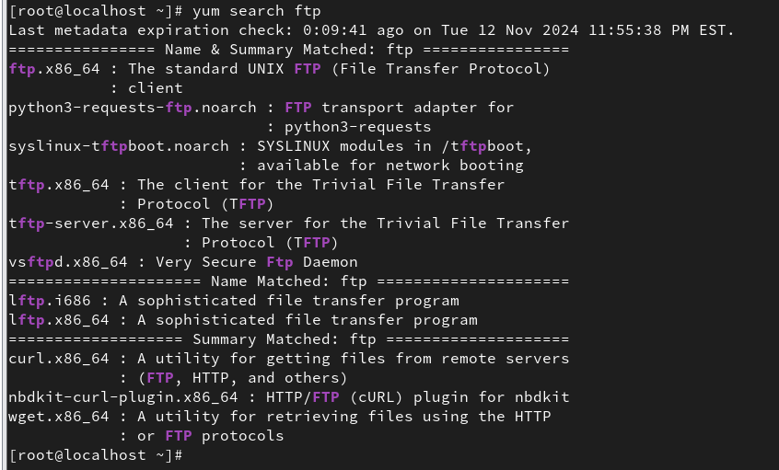

1. yum search Apache Serve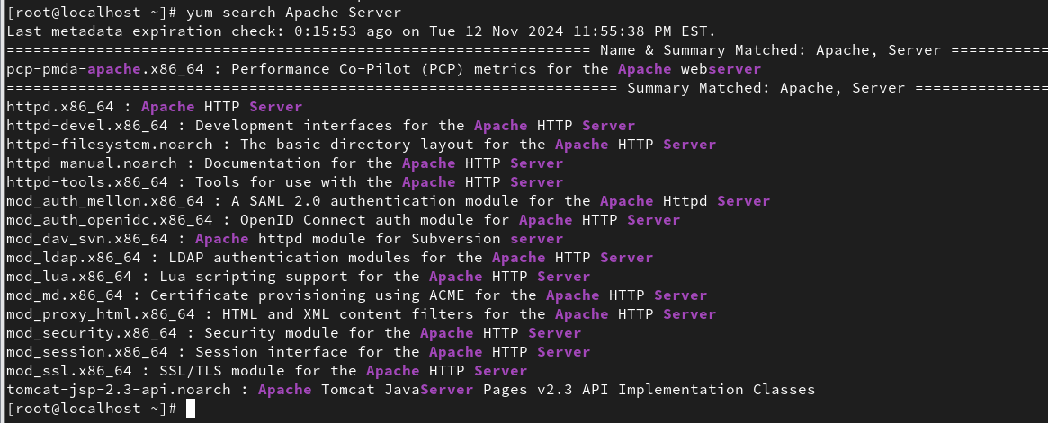r
2. yum info vsftpd ( rpm -qi vsftpd)

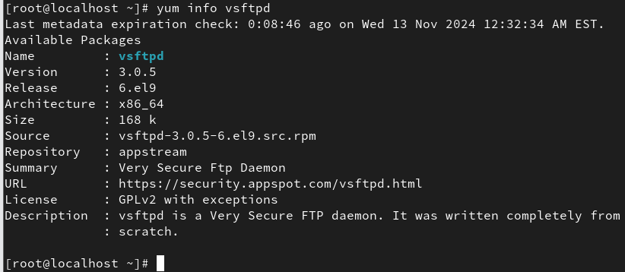

1. List packages
   1. yum list | less (lists all available packages)

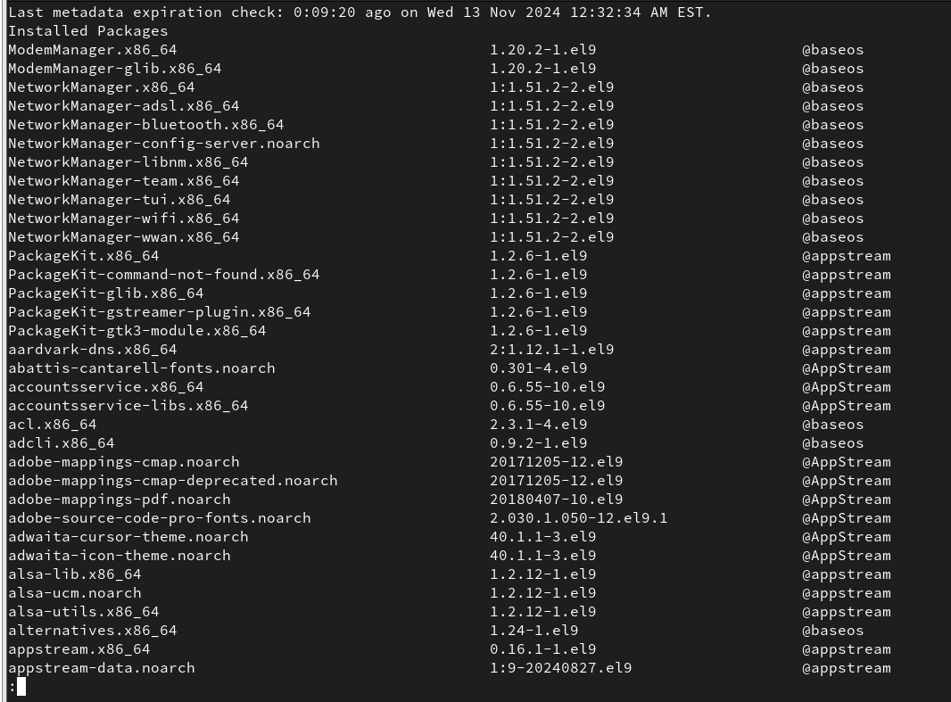

* 1. yum list installed | less (list all installed packages using yum)

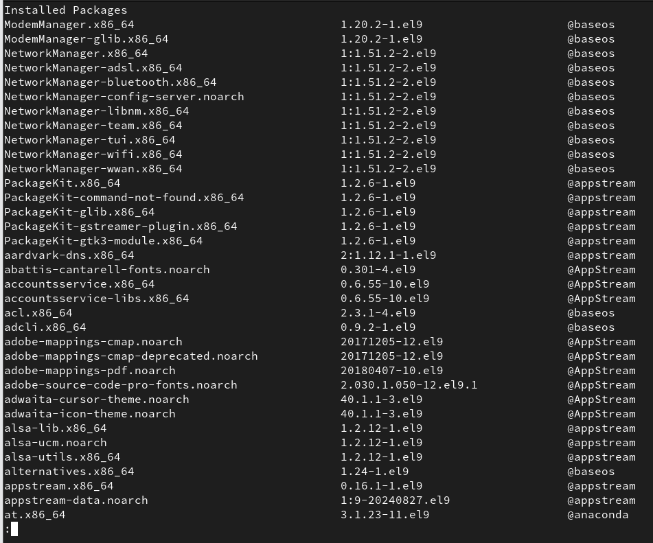

1. yum check-update (checks for available updates)

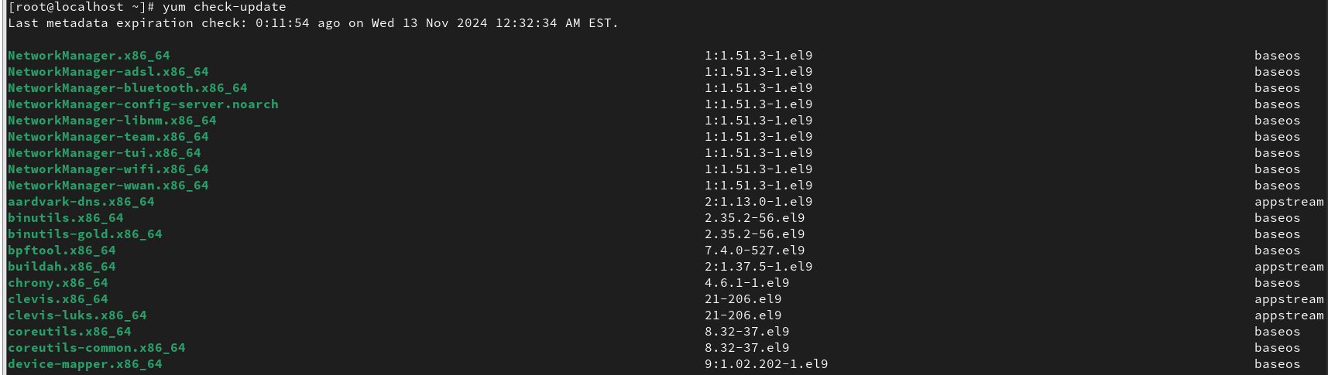

1. yum update ( updates the system)

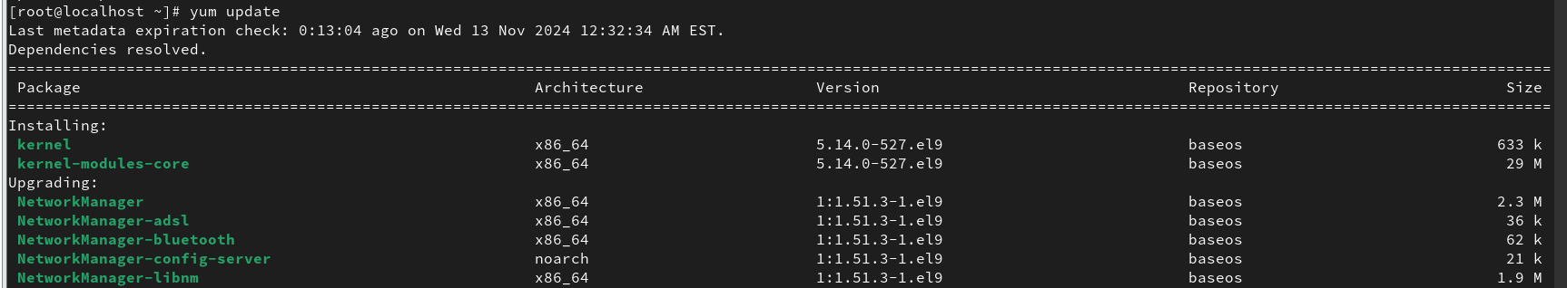

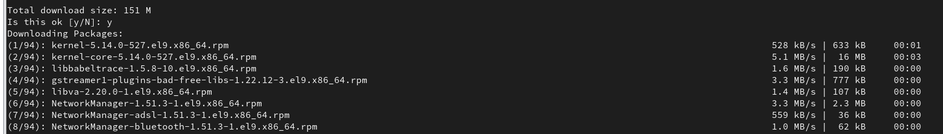

1. yum repolist (list enabled yum repositories)

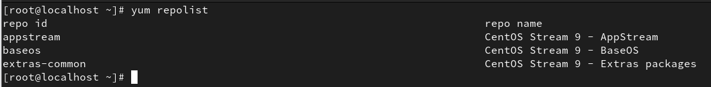

1. yum repolist all (list all enabled and disabled repos)

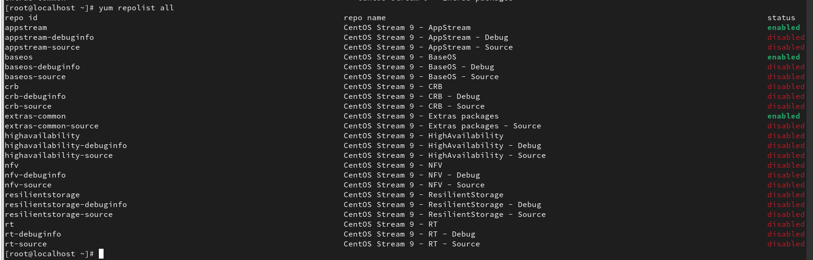

1. yum clean all (clear the yum cache)

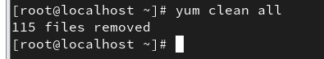

1. yum history (list all the tasks done with yum)

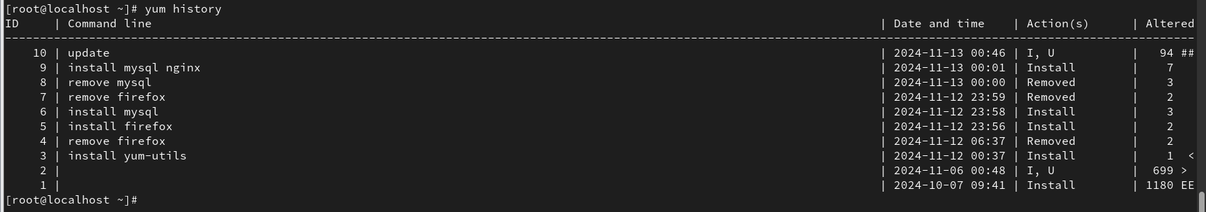

1. yum history undo taskid (rollback task) – yum history undo 19

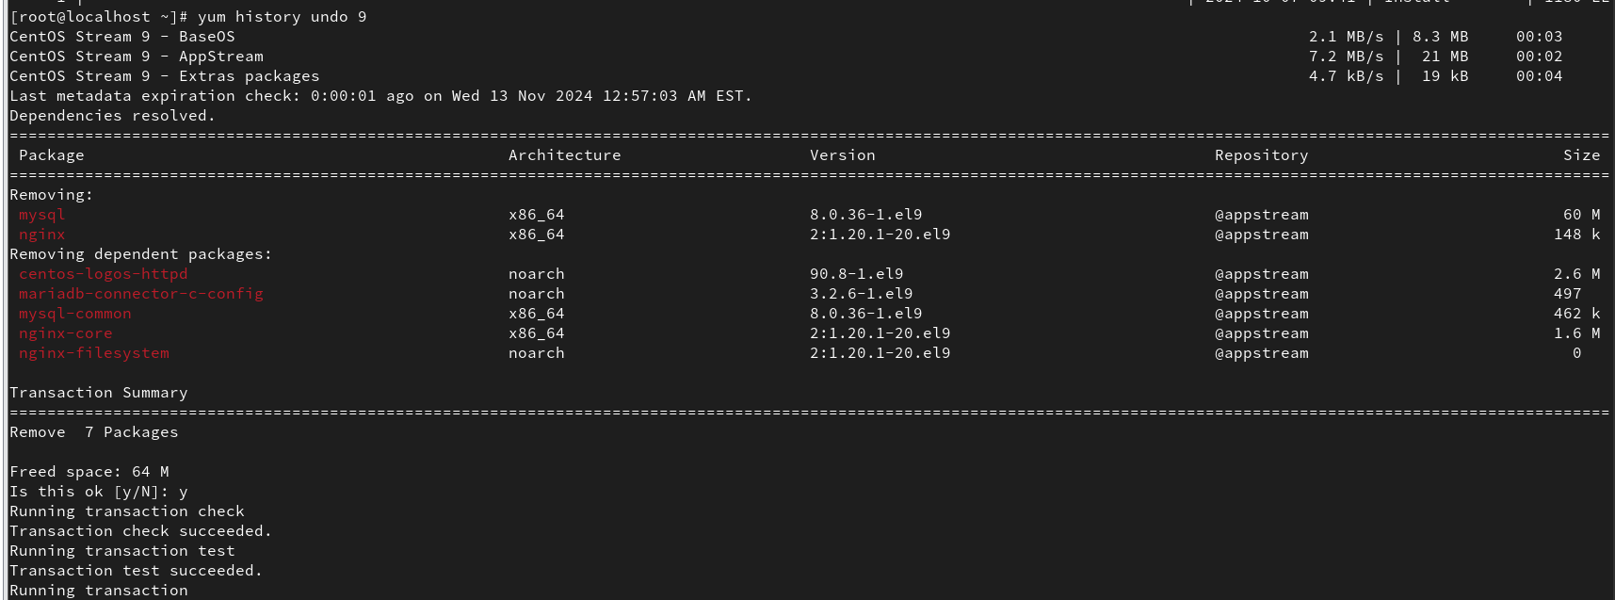



1. yum redo taskid (redo the task) – yum redo 17

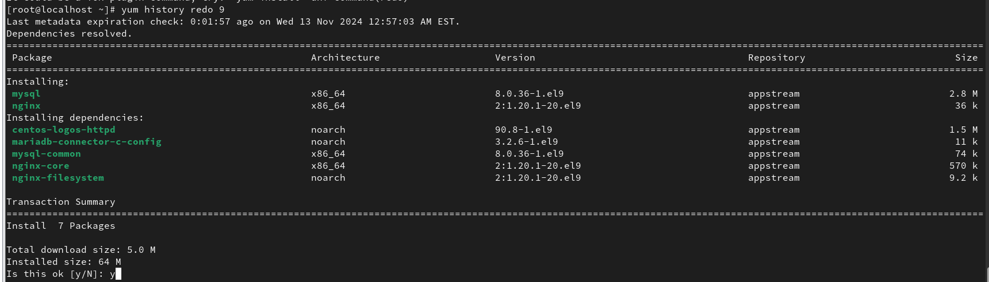



1. search a package containing the file – same as (rpm -qf path/of/file)
   1. yum provides /usr/bin/getfacl

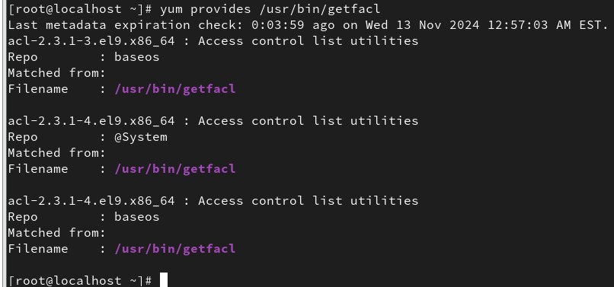

* 1. yum provides /etc/vsftpd

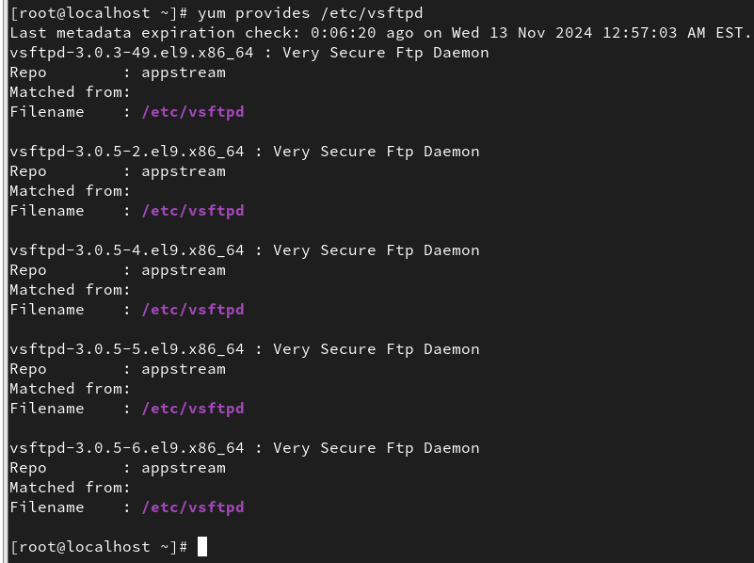

* 1. yum provides /usr/bin/ping

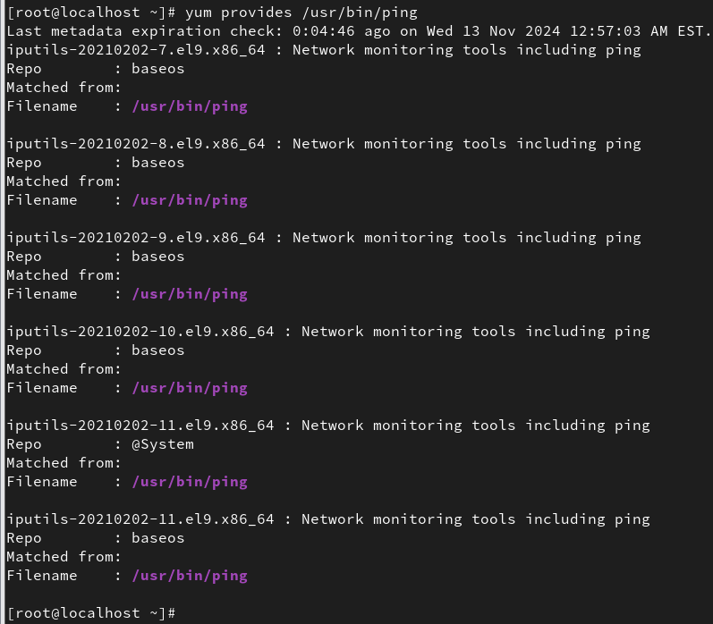

1